**Report on the project of CSE326**:-

*GROUP-20* *SECTION-K19HK*

MEMBERS-RAJVARDHAN RATHORE(ROLL 59),NIKHIL SOREN(ROLL 60),AMIT TAMRAKAR(ROLL 58)

PROJECT NAME-ONLINE SHOPPING WEBSITE

WORK DISTRIBUTION :

AMIT TARMRAKAR: PRODUCT DESRCRIPTION PAGES OF ITEMS AND LOGIN/SIGN UP ARE MADE BY HIM.(Table consisting of clothing,mobile phones&clothe1.html,clothe2.html etc)

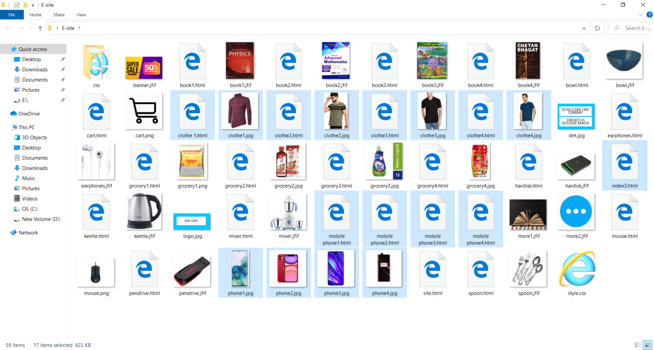

RAJV ARDHAN RATHORE:WEBSITE LAYOUT DESIGN AND ALSO HELPIING IN MAKING THE DESCPRIPTION PAGES.(SINCE HE IS LIVING IN JAMMU WHERE LOW INTERNET AVAILABILITY IS THERE ,SO HE WAS FACING INTERNET ISSUE .SO HE ACT AS THE SUPPORT MEMBER FOR PROJECT MAKING).[grocery and css part of code done by him]

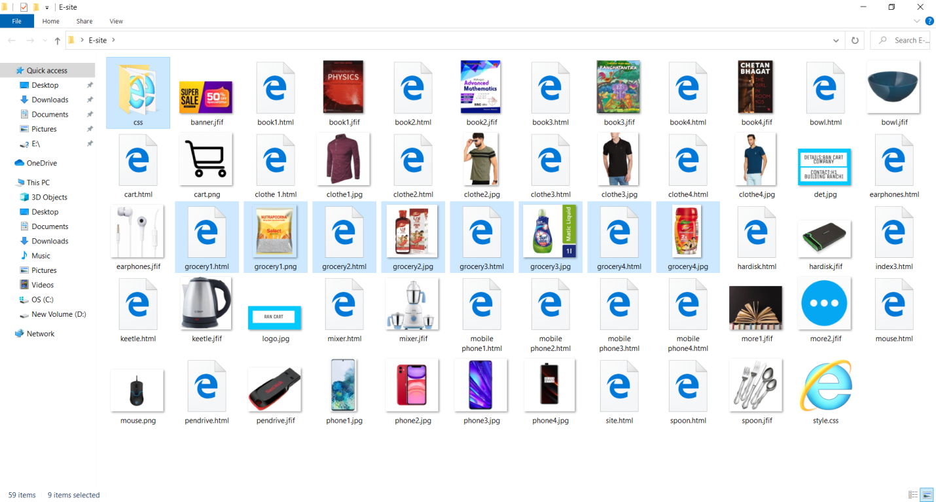

NIKHIIL SOREN: THE FRONT PAGE, PAYMENT SECTION PAGE ALSO ADD TO CART PAGE ALSO SOME OF THE PRODUCT DESCRIPTION ARE MADE BY HIM.

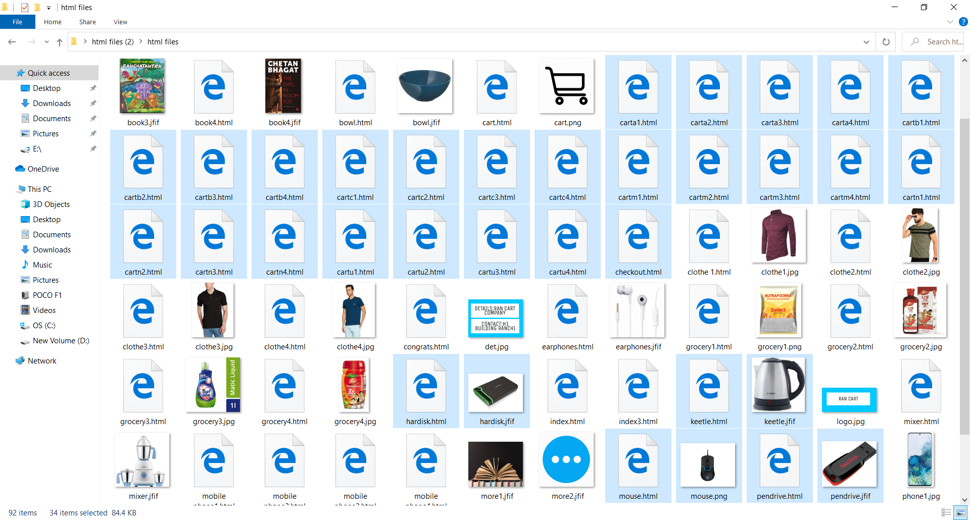

**SUMMARY:**

* The project consists of making up of website which is named as “RAN CART”.

* It is an e-commerce website .

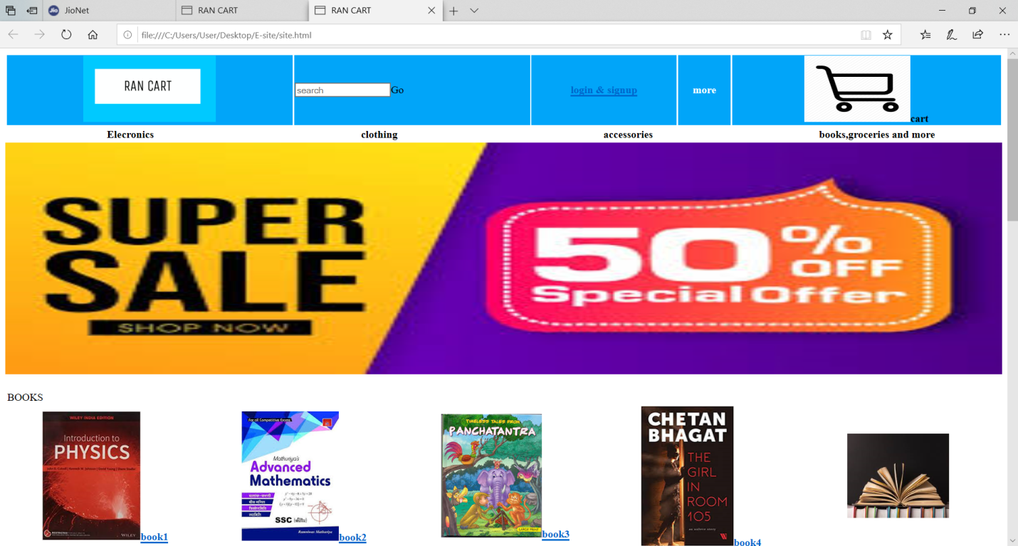

*It provides user to search the items for all kinds.

*Items are ranging from clothing, groceries, electronic gadgets and books etc.

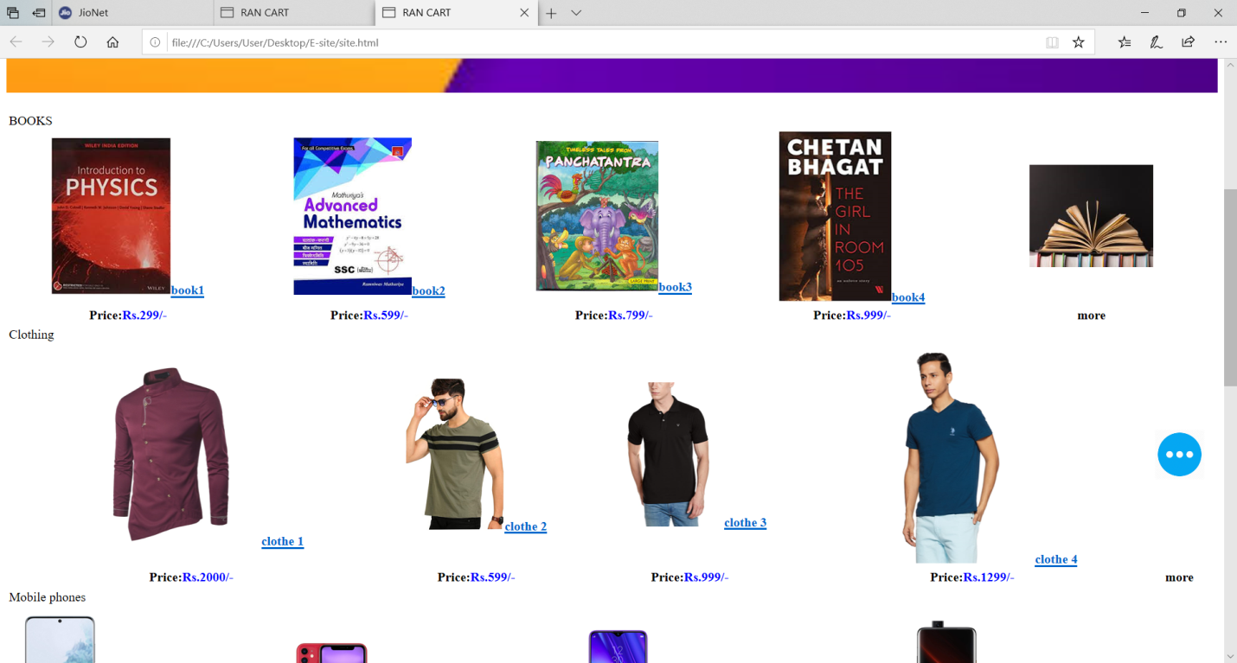

*The user has to make an id on website to buy any things.

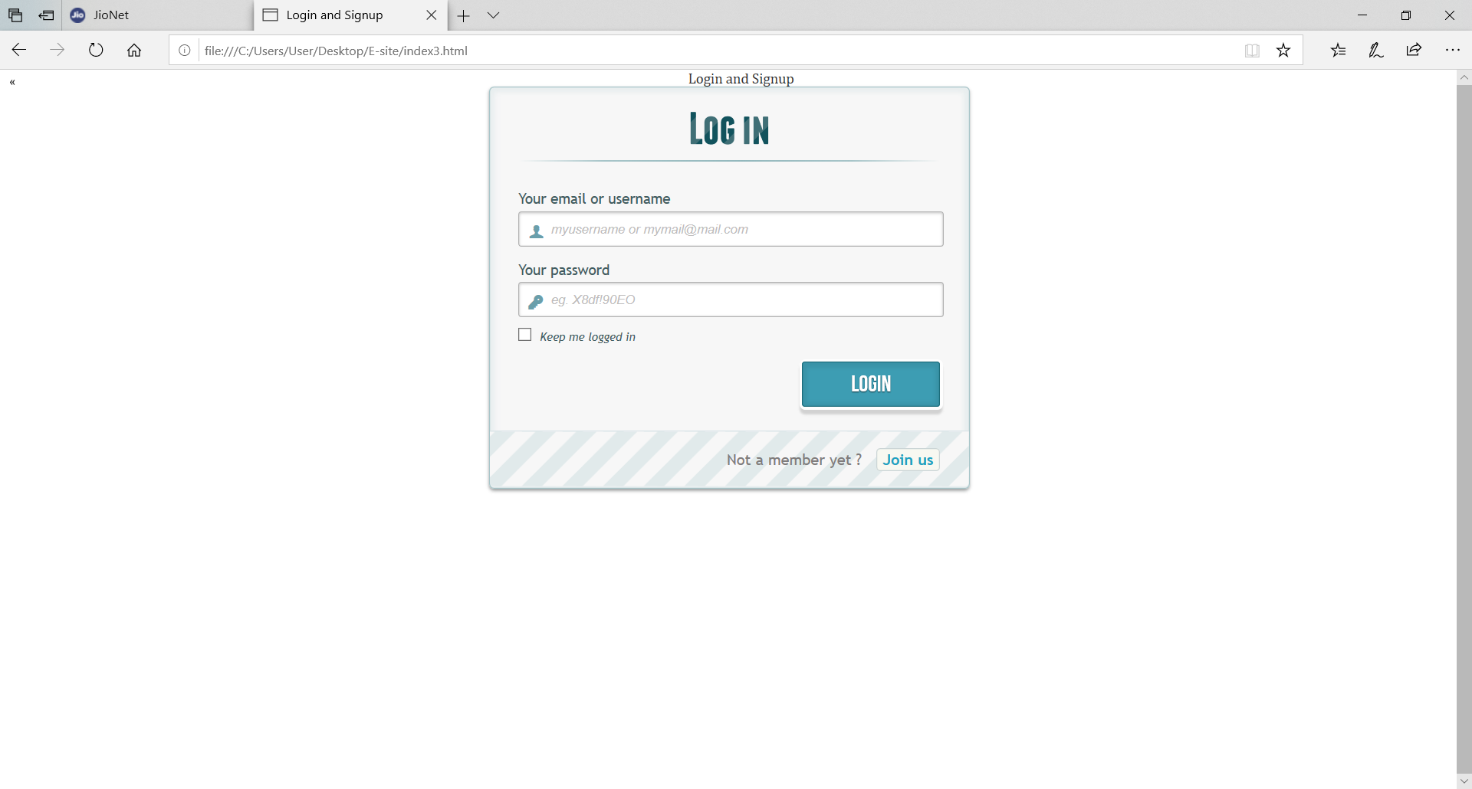

*Through descriptions of items are given.

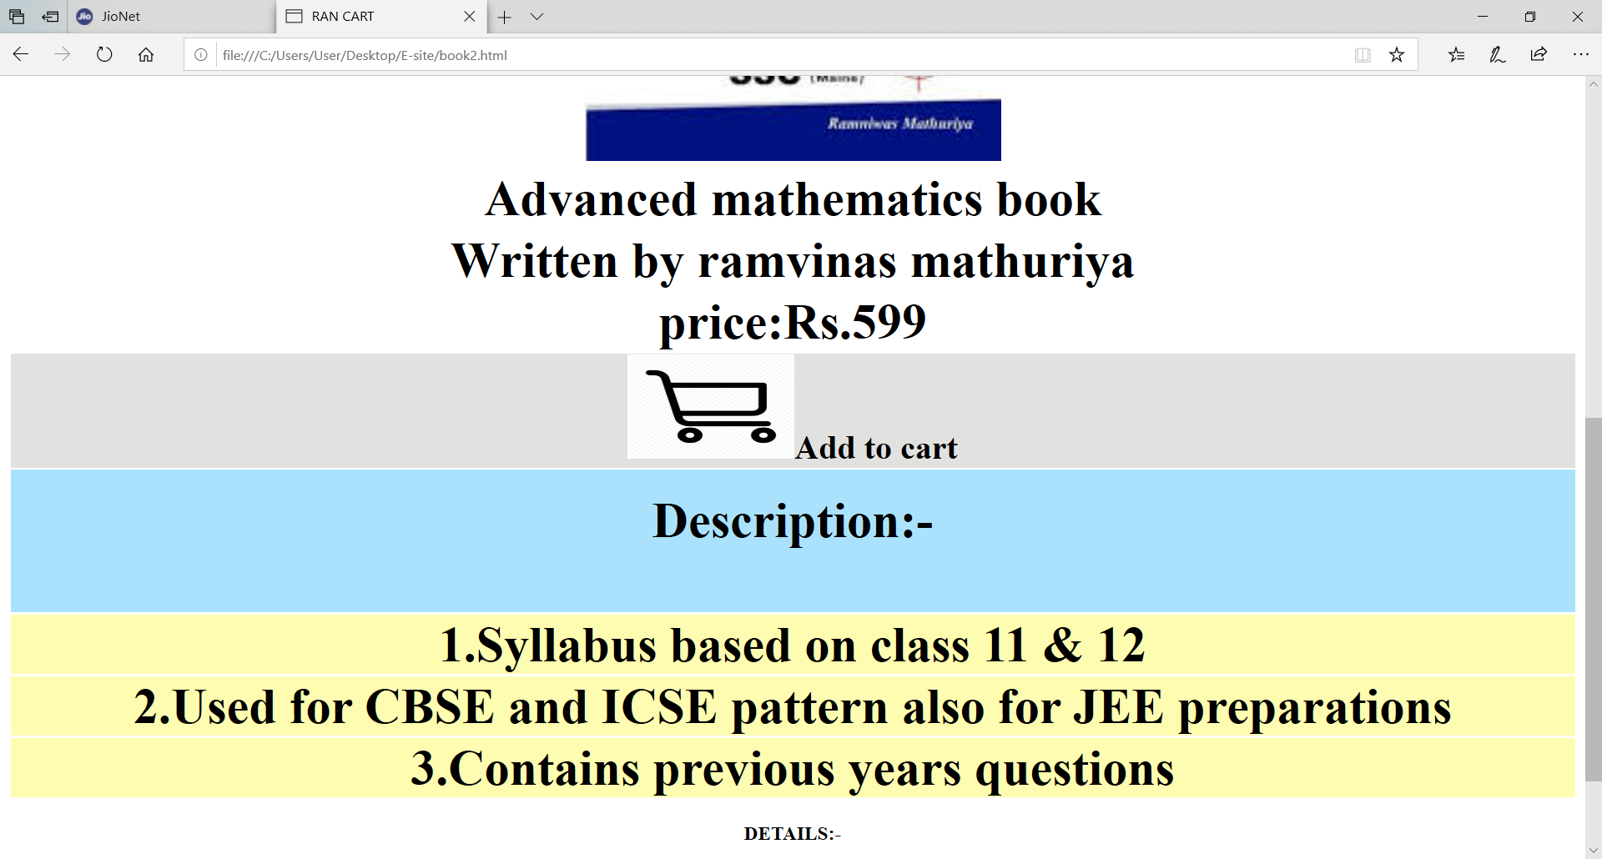

*payment options of COD/Debit/Credit card are available.

**Working:**

*All the components used inside the file are kept in folder E-site.

* The site is run from the html file named “site.html”.

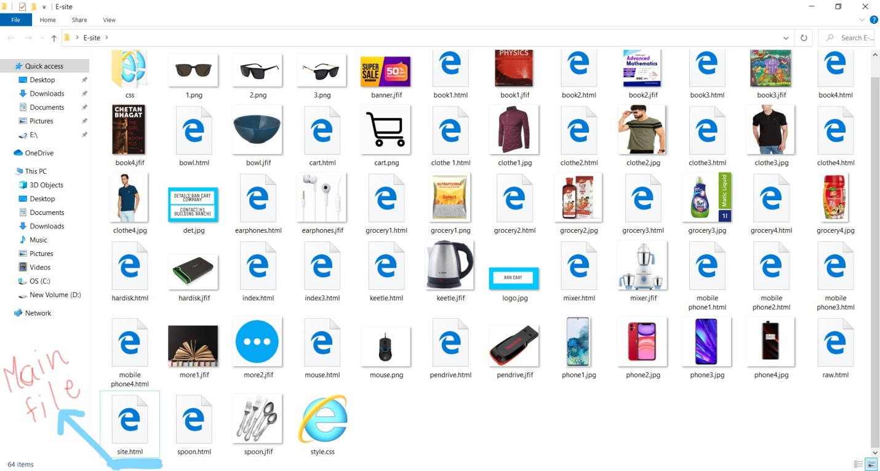

*All other respective files along with their source html/css code and images are kept inside the folder only.

*The left-top corner of the pages provide the name of the site.

* The front row consists of “search bar”, login, sign option and cart option.



*THE further row gives the details of categories.

*A picture is provided with showcasing the offer.

*Rest rows shows the available items along with their price for shopping.

*The bottom row provides the details of the website.

**EXPLAINING OF CODE OF PAGES:-**

**\*THE FRONT PAGE**

:Body consist in the table format.

:First row is made with inscretion of “logo.jpg”&” cart.jpg”.

:Also a link is provides to access file of “index3.html”.

:”index3.html” is the sign up/login page of the website.

:The books/phones all other items are provided with their picture and descriptive link extension with can be accessed with their buttons.

Eg.<a href=”book1.html”>book1;here book1 act as button.

Same as for other items. Html code screenshot

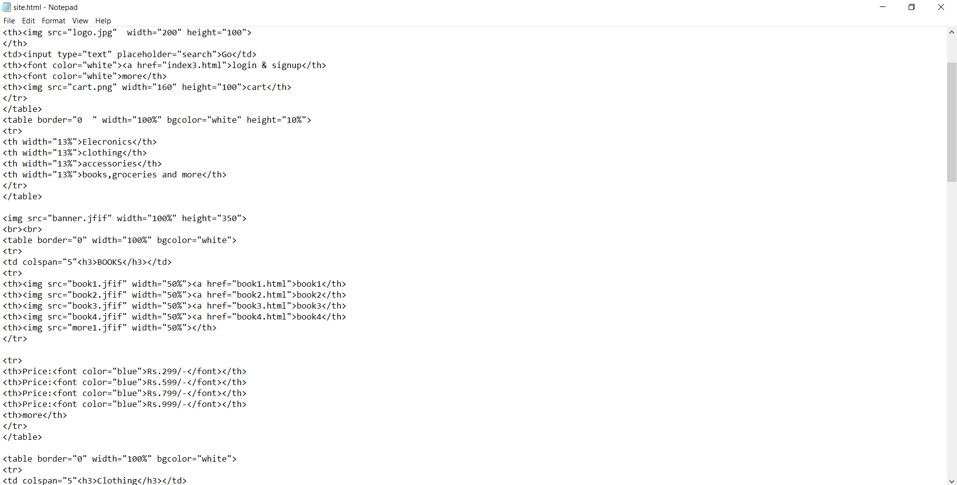

:The pricing are kept on Indian rupee.

:The detail section is been kept normal address and company name.

**DESCRIPTION PAGES:**

:The description pages are also made with the front row consisting of logo,search bar,and cart and login/sign up.

:A large image of item is provided with its pricing and description.

:The user can add the item in the cart[pressing on add to cart button].

: After clicking it ,user is directed to cart page where he can see his inventory and then procedd to payment gateway.

:The cart page

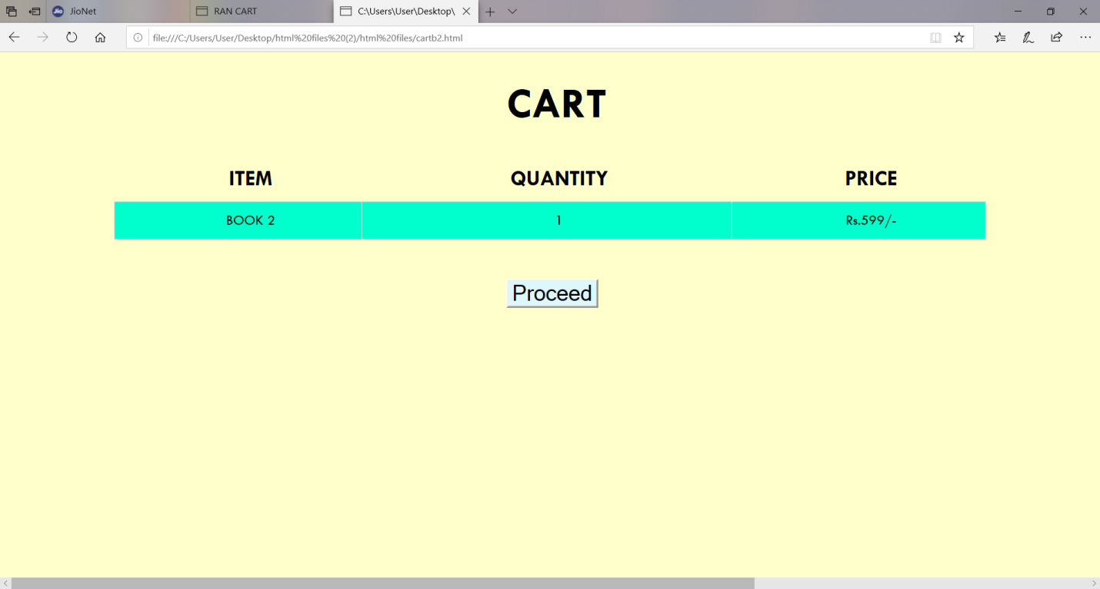

:payment page:

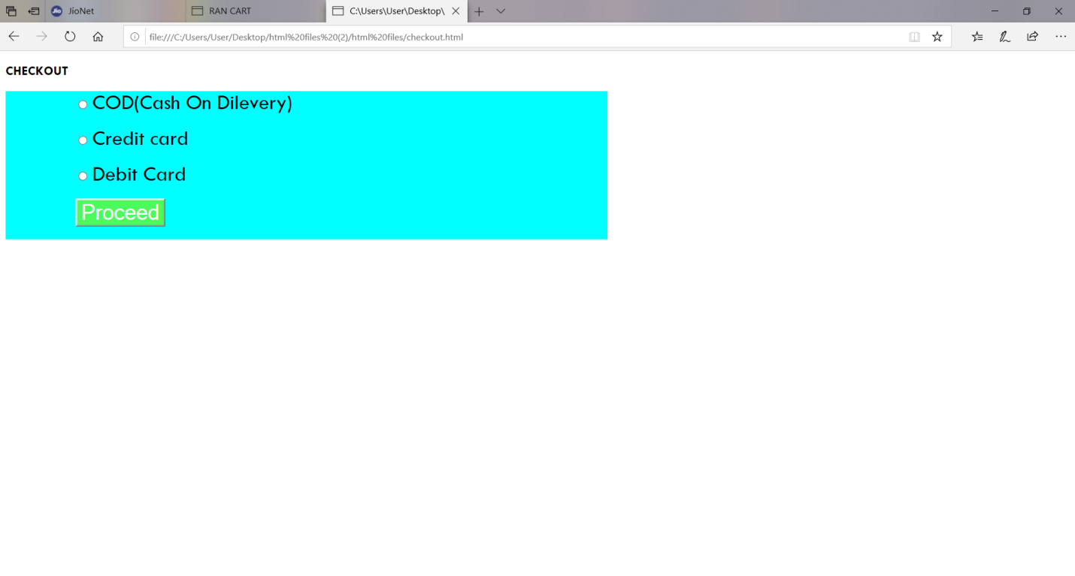

The end